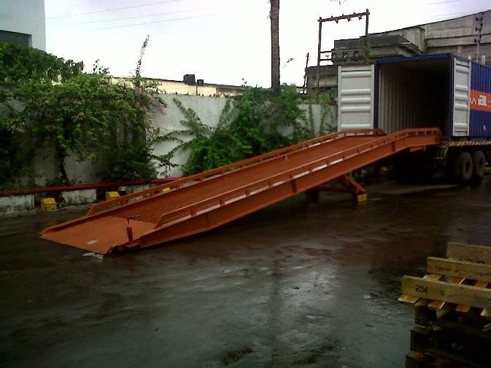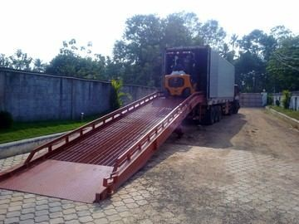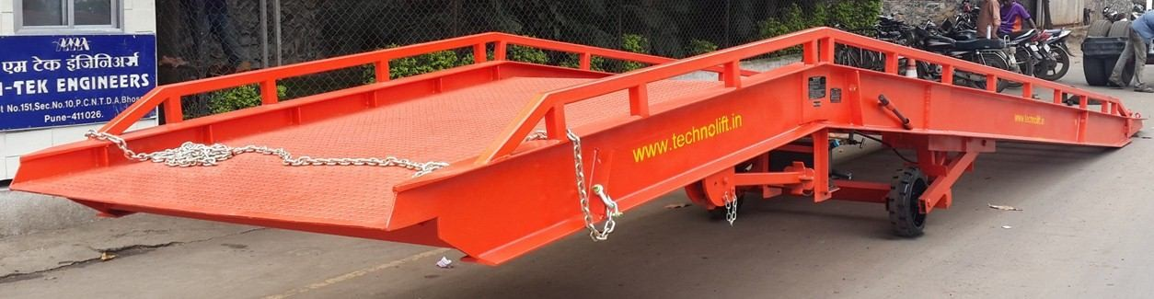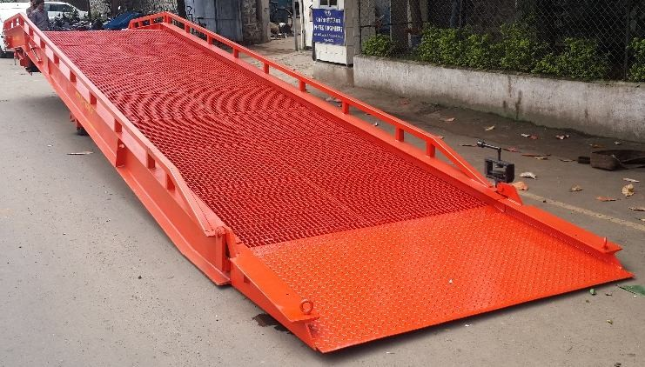

10 to 15 Ton Capacity - Mobile Ramp

Container loading Application

Heavy Duty Construction Lip rest on Container Bed / Chain Locking

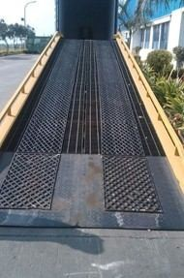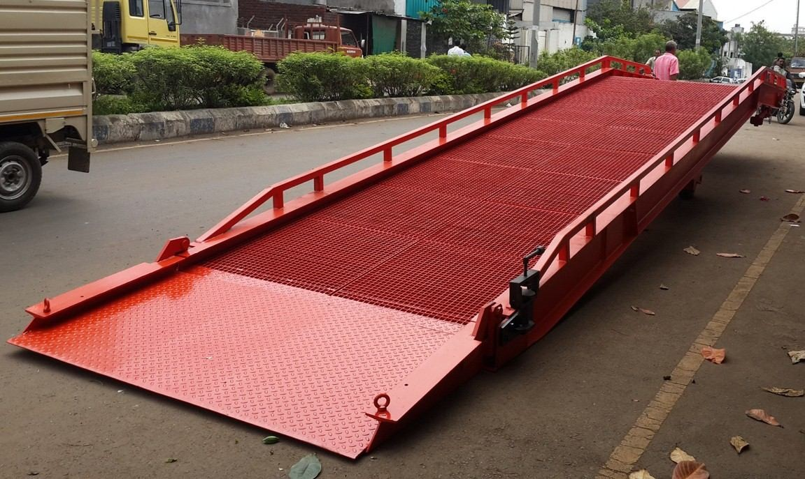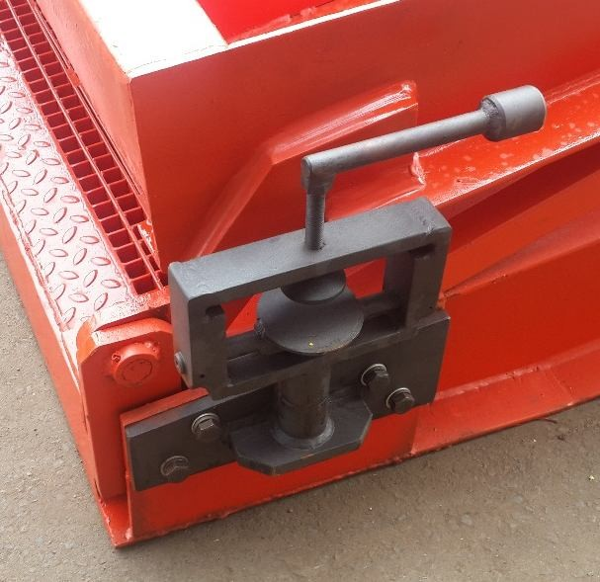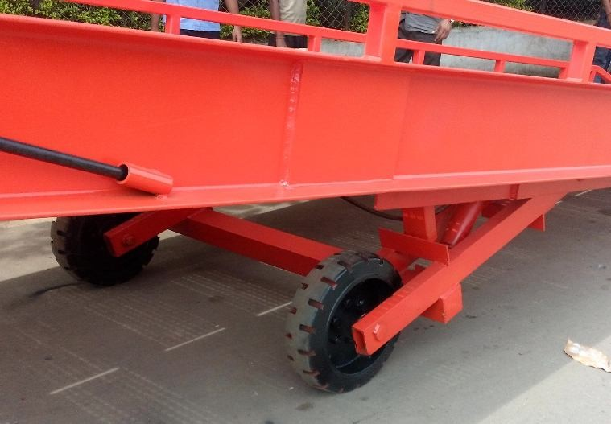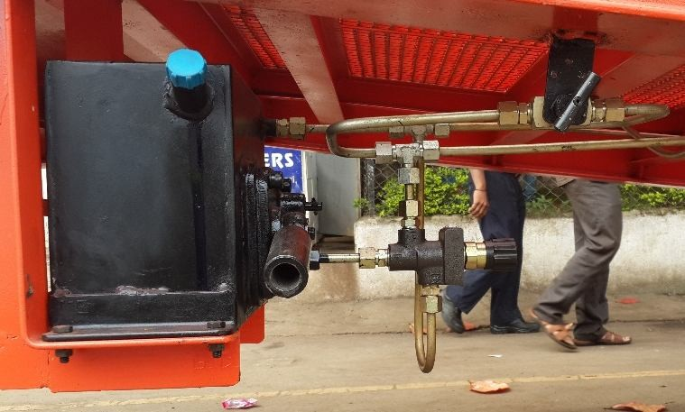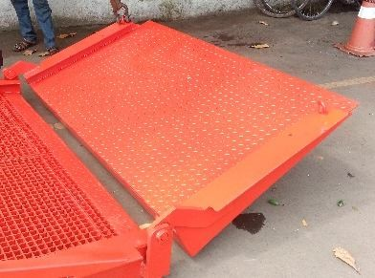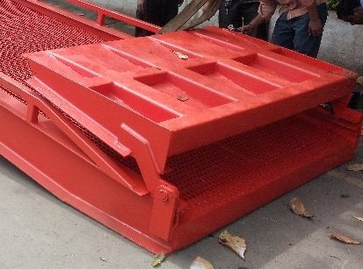

Standard Grating Customized Grating

Fork Locking - Easy to Move Solid Rubber Tyre

Hydraulic Pump / Steel Piping Entry Platform


TECHNICAL EVALUATION SHEET
EQUIPMENT NAME : MOBILE DOCK RAMP
Manufacturer- TECHNOSYS EQUIPMENTS PVT LTD
SR No. | Elements | Description
A | EQUIPMENT TECHNICAL DETAILING
1 | EQUIPMENT EFFECIENCY | 100%
2 | MODEL | TMR10
3 | CAPACITY (Kgs) | 10000 Dynamic
3 | CAPACITY (Kgs) | 12000 Static
4 | SIZE L X W (mm) | 2000 X 11500
5 | Lip Extension (mm) | 350
6 | Working Range Above & Below (mm) | 1200 / 1600
7 | Operation | Hydraulically
B | EQUIPMENT COLOR CODING
1 | Corrosion Resistance: | Painted
C | INSTALLATION & COMMISIONING
1 | Training on Operation & Maintenance | Provided
2 | One of Sets of Manuals clearly indicating the parts, dwgs, specifications, Operation & Maintenance | List shall be provided
D | OPERATION
1 | Equipment to be used for loading & unloading | Fork Lift (up to 25 % Gradeability)
2 | Containers used for Loading / Unloading | STANDARD
E | Warranty | 12 MONTHS from the date of installation


